# Real-world use cases of NoSQL databases

**1. Retail**

* **Product Catalogs**: NoSQL (especially document stores like MongoDB) can handle diverse product attributes without a fixed schema.
* **Customer Personalization**: Storing user behavior and preferences for personalized recommendations.
* **Inventory Management**: Real-time tracking of stock levels across multiple locations.
* **Omnichannel Data Integration**: Aggregating data from online, mobile, and in-store systems.

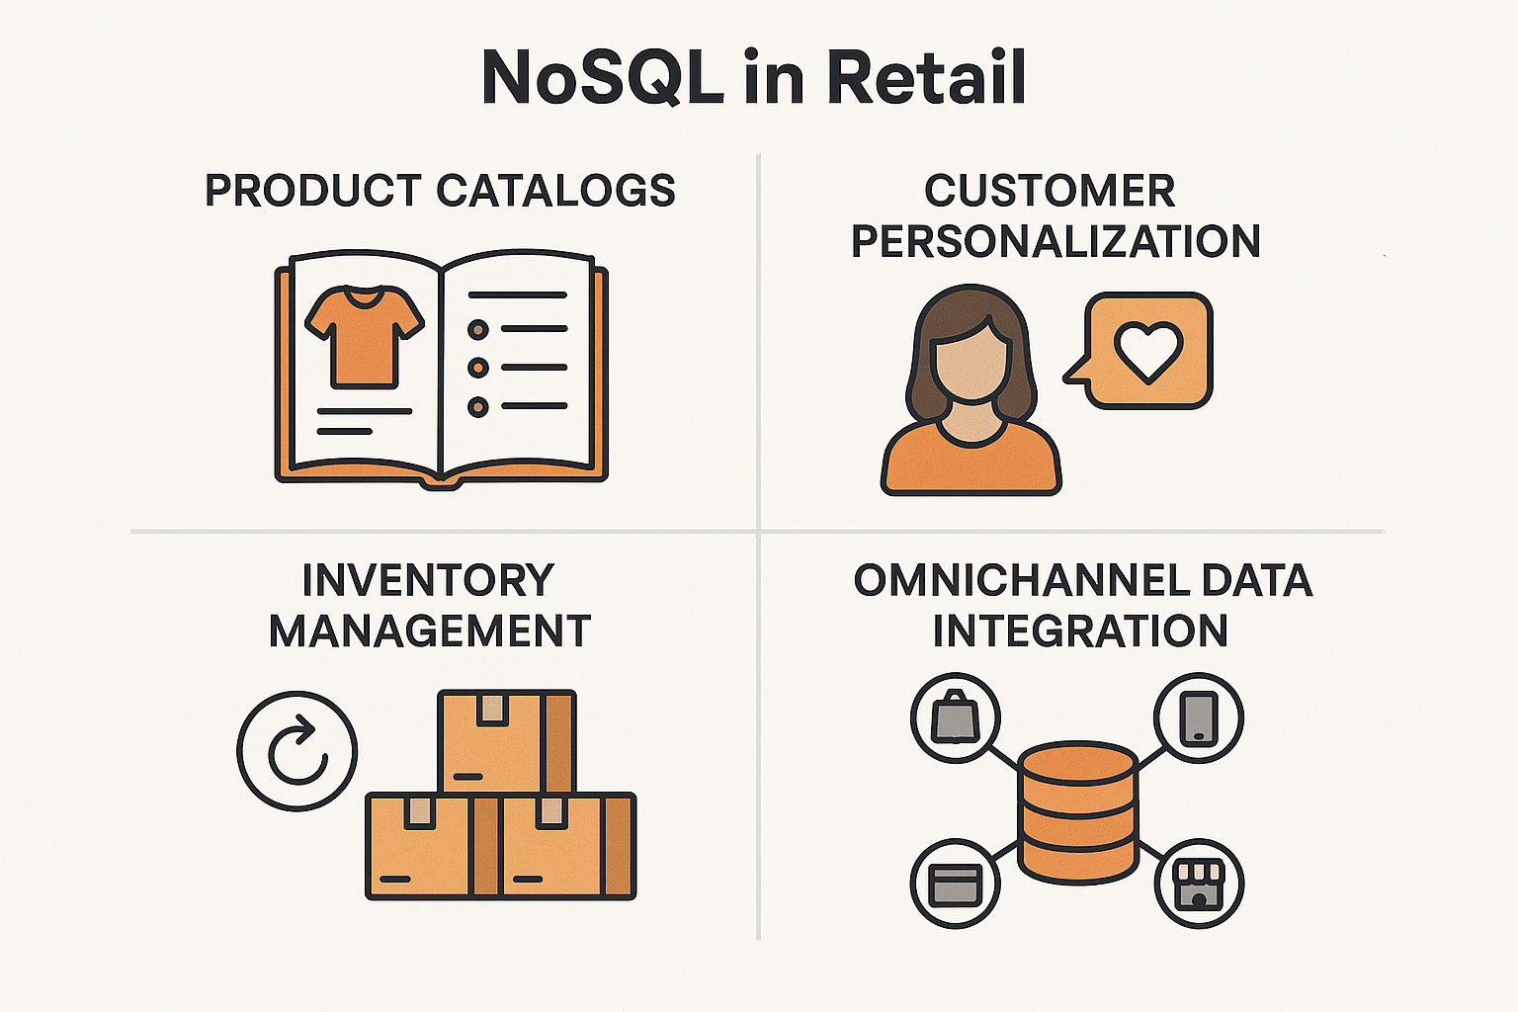

**2. Banking**

* **Fraud Detection**: Storing and analyzing large volumes of transaction data in real-time.
* **Customer 360 View**: Aggregating customer data from multiple sources for a unified profile.
* **Log and Audit Trails**: Using NoSQL for immutable, scalable logging systems.
* **Mobile Banking Apps**: Fast, flexible data storage for user sessions and preferences.

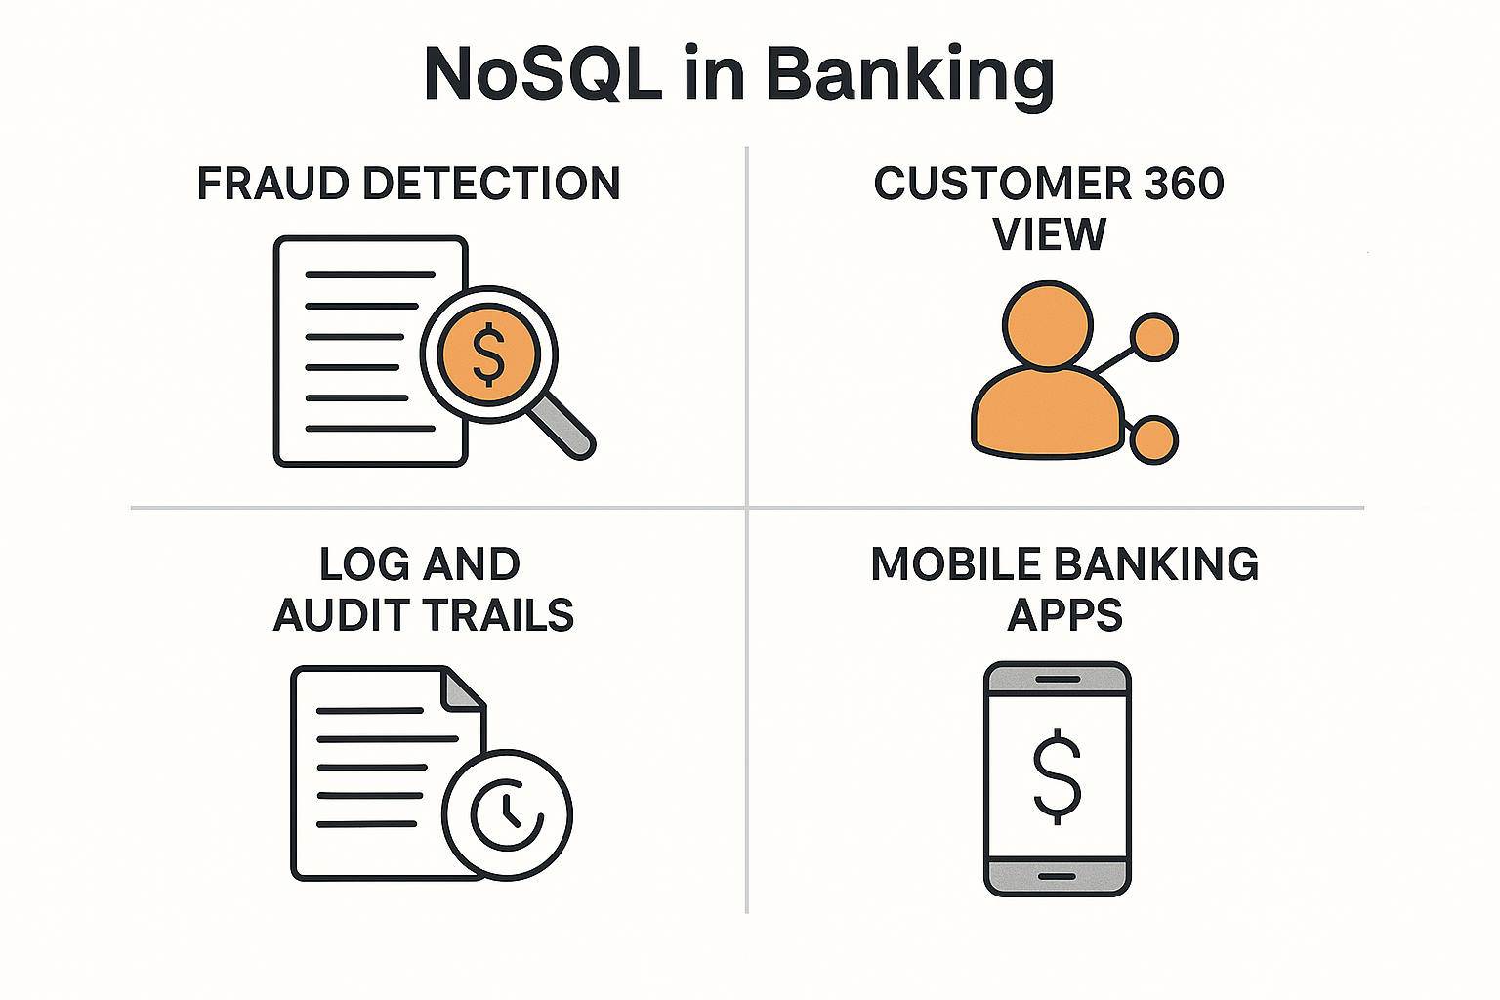

**3. Social Media**

* **User Profiles and Posts**: Schema-less storage for varied content types (text, images, videos).
* **Real-Time Feeds**: High-speed ingestion and retrieval of user-generated content.
* **Friend Graphs**: Graph databases (like Neo4j) to model relationships and connections.
* **Analytics and Trends**: Storing and querying massive datasets for engagement metrics.

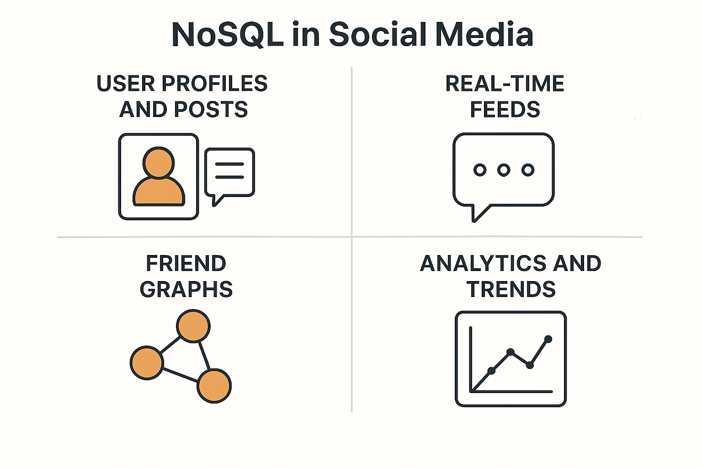

**4. Education**

* **Learning Management Systems (LMS)**: Flexible storage for courses, quizzes, and student progress.
* **Student Records**: Handling diverse data formats for academic history, attendance, and feedback.
* **Collaborative Platforms**: Real-time chat, document sharing, and discussion forums.
* **Adaptive Learning**: Storing behavioral data to personalize learning paths.

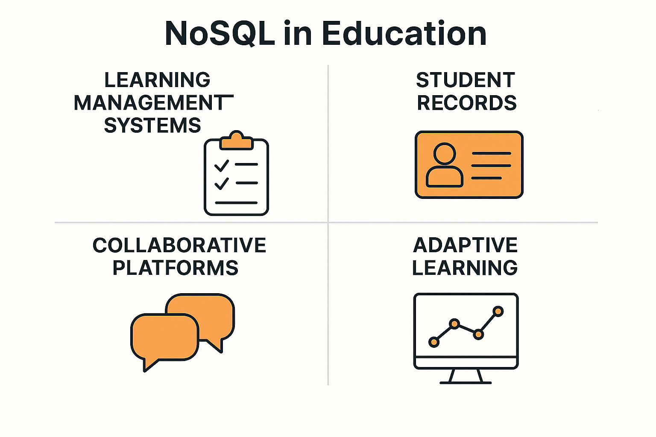

**5. Healthcare**

* **Electronic Health Records (EHR)**: Storing patient data with varying formats and structures.
* **Medical Imaging Metadata**: NoSQL can store metadata for large image files (e.g., X-rays, MRIs).
* **IoT and Wearables**: Real-time data ingestion from health monitoring devices.
* **Clinical Research**: Managing unstructured data from trials, notes, and genomic data.

